Source org : [nishanthmandala@salesforce.com](mailto:nishanthmandala@salesforce.com)

Destination org: [rednishanth@salesforce.com](mailto:rednishanth@salesforce.com)

Requirement : When account is created in source org, should automatically push this account into Dest org

Step 1: Create Connected App in Destination Org. Call back URL should be Source URL.

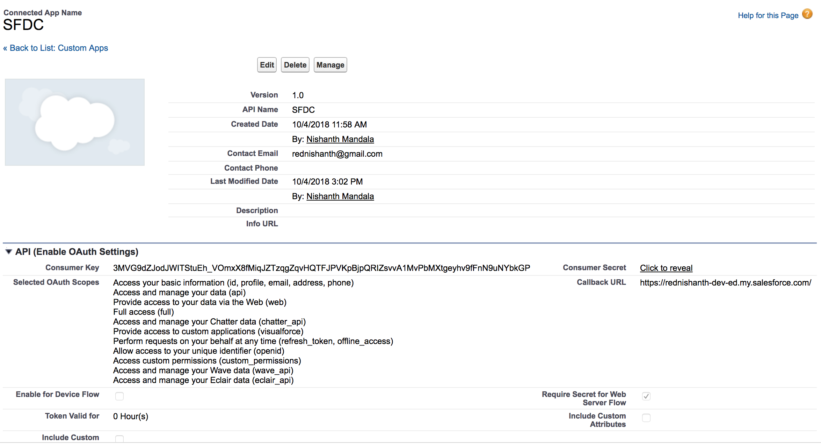

Step 2: Create class in Destination Org to consume rest resource.

Class name: REST_AccountService_V4

Step 3: Create remote site settings and destination URL in source org.

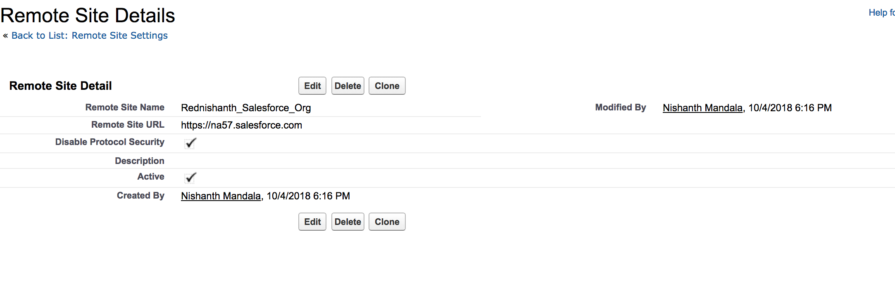

Step 4: Create Rest Call out class in Source Org. Give the client id and customer key in the class.

Class name: SendAccount123